**Arduino IDE**

This is where we write our code. It's a bit like a word processor for coding. There are lots of IDEs available. This one is set up specifically for Arduino.

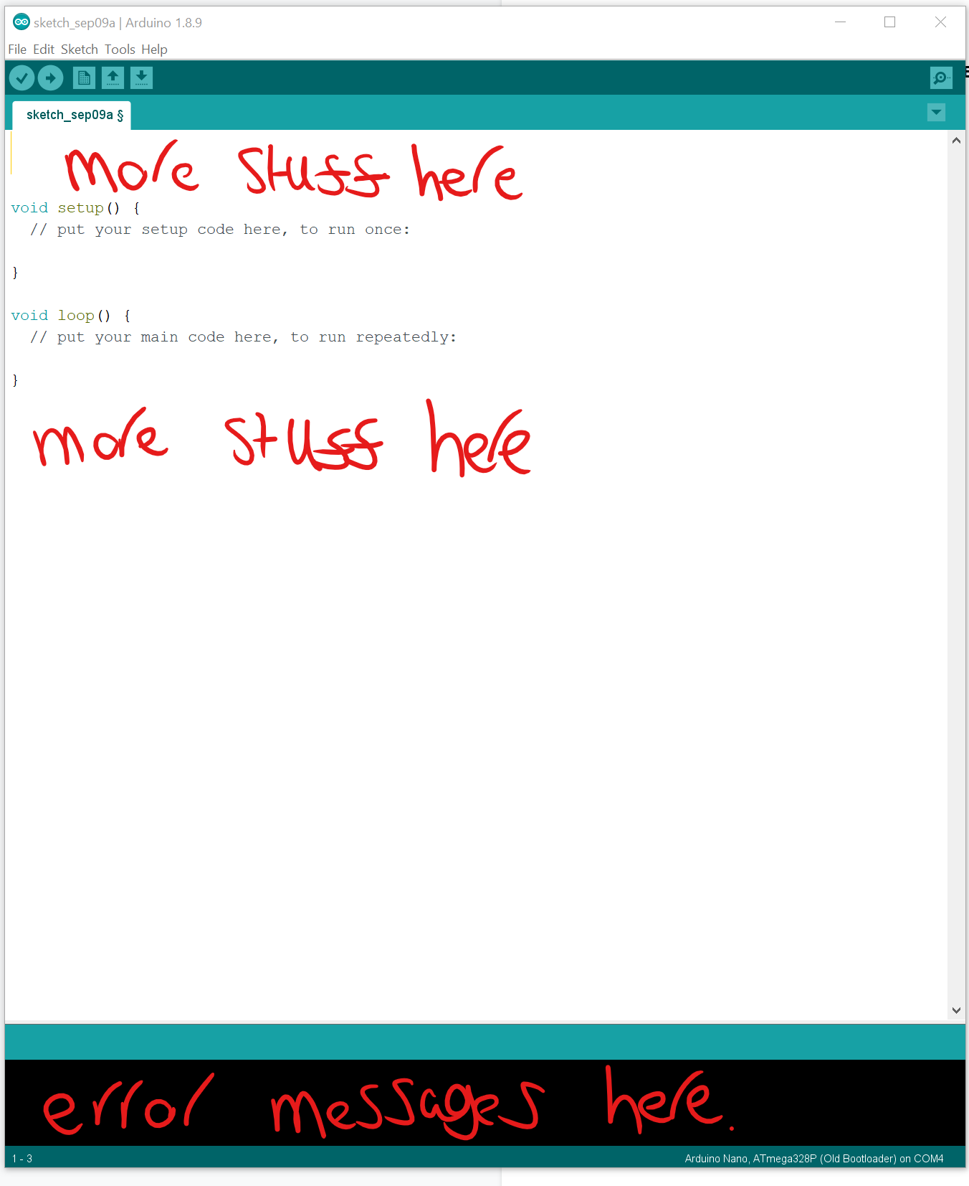

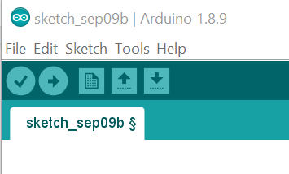

**Left to Right**

**Verify ( Compile)** - Checks our code is correct. Turns it into code that will run on the Arduino board

**Upload**. - Does as the Verify does and then sends the code to the Arduino board

New - Creates a new Sketch.

Open - Opens an existing sketch.

Save - saves our sketch.

**Tools.**

**Board Manager.**

Make sure the board you have is selected.

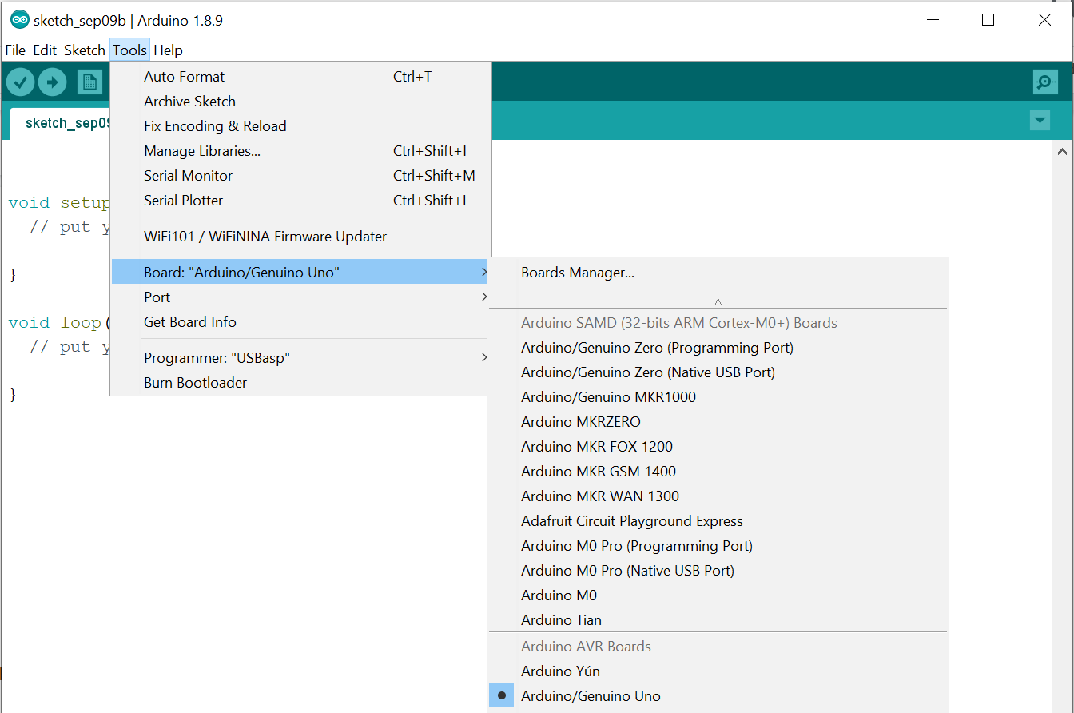

**Ports**

When your Arduino is connected a port will appear in here. On a Windows computer it will be called COMxx where xx is a low number. I.e COM3, COM4 etc. On a Mac it will vary but will usually be have usbmodem, usbserial or similar in the name. There may be multiple entries.

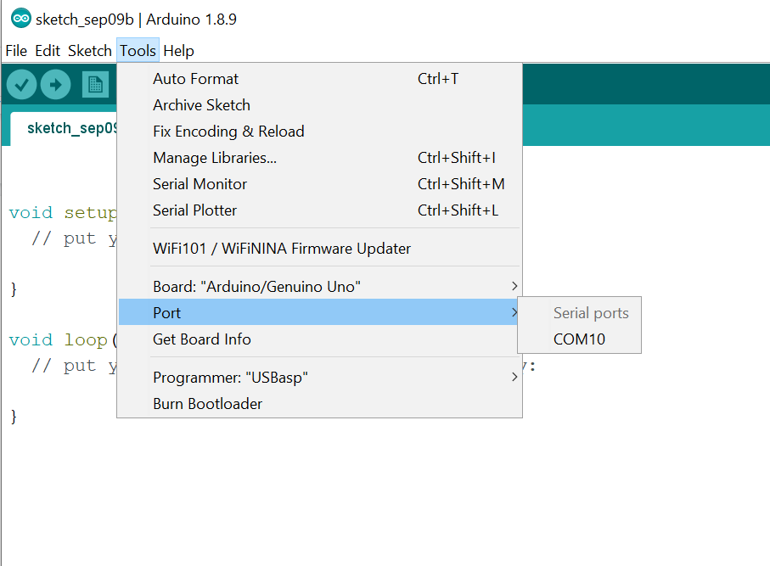

If you aren’t sure which is the Arduino. Check the list before plugging in and then again after plugging in.